LINEAR REGRESSION
First, let´s talk about the main ideas behind linear regression (aka GENERAL LINEAR MODEL):
- Use least-squares to fit a line to the data
- Calculate $R^{2}$
- Calculate a p-value for $R^{2}$
- Use the model for predictions
Let´s do a quick review, and introduce some new terminology …
LEAST-SQUARES
Our goal is to use mouse weight to predict mouse size:
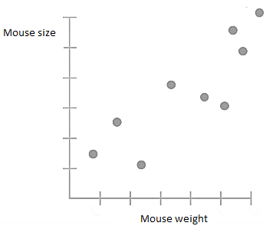
1st, draw a line through the data.
2nd, measure the distance from the line to each data point, square each distance, and add them up.
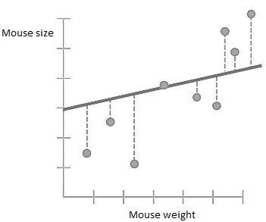
TERMINOLOGY ALERT: the distance from a line to a data point is called a RESIDUAL.
3rd, rotate the line a little bit, and measure the new residuals, square them, and add them up.
4th, now rotate the line a little bit more, calculate residuals, etc
…
After a bunch of rotations, we can plot the SSR with their corresponding rotation:
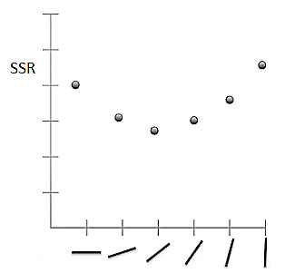
Lastly, we find the rotation that has the least sum of squares.
So, LEAST-SQUARES estimated two parameters (slope and intercept of the line). Here´s the equation for the line:
$$y=\underset{intercept}{\underbrace{0,1}}+\underset{slope}{\underbrace{0,78}} x$$
R-SQUARED
Since the slope is not 0, it means that knowing a mouse´s weight will help us make a guess about that mouse´s size. But how good is that guess? Well, calculating $R^{2}$ is the first step in determining how good that guess will be.
1st, we calculate the average mouse size.
$$\overline{y}=\frac{y_{1}+y_{2}+…+y_{n}}{n}$$
$$y_{i}:observed size for mouse-i$$
$$n:sample size$$
2nd, we measure the distance from the mean to each data point and square it, then add them up.
$$SS\left(\overline{y}\right)=\sum_{i=1}^{n}{{\left(\overline{y}-y_{i}\right)}^{2}}=100$$
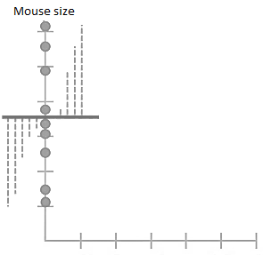
TERMINOLY ALERT: we´ll call this SS(mean) for sum of squares around the mean.
We also calculate the average sum of squares per mouse:
$$Var\left(\overline{y}\right)=\frac{\sum_{i=1}^{n}{{\left(\overline{y}-y_{i}\right)}^{2}}}{n}=\frac{SS\left(\overline{y}\right)}{n}=11,1$$
TERMINOLY ALERT: we´ll call this Var(mean) for variation around the mean.
3rd, go back to the original plot, and sum up the squared residuals around the fitted line:
$$SS\left(\tilde{y}\right)=\sum_{i=1}^{n}{{\left(\tilde{y}-y_{i}\right)}^{2}}=40$$
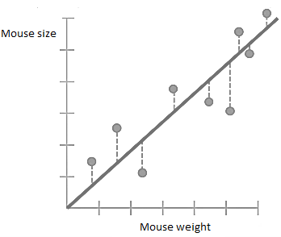
TERMINOLY ALERT: we´ll call this SS(fit) for sum of squares around the least-squares fit.
We also calculate average SS(fit) for each mouse:
$$Var\left(\tilde{y}\right)=\frac{\sum_{i=1}^{n}{{\left(\tilde{y}-y_{i}\right)}^{2}}}{n}=\frac{SS\left(\tilde{y}\right)}{n}=4,4$$
TERMINOLY ALERT: we´ll call this Var(fit) for the variance around the fit.
OK, so far, we calculated the raw variation in mouse size and the variation around the fitted line:
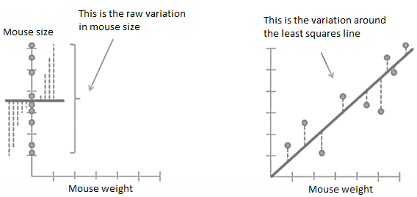
There is less variation around the line that we fit by least-squares. That is to say, the residuals are smaller. As a result, we say that some of the variation in mouse size is explained by taking mouse weight into account.
In other words, heavier mice are bigger and lighter mice are smaller.
$R^{2}$ tells us how much of the variation in mouse size can be explained by taking mouse weight into account.
5th, we calculate R-squared:
$$R^{2}=\frac{Var\left(\overline{y}\right)-Var\left(\tilde{y}\right)}{Var\left(\overline{y}\right)}$$
$$R^{2}=\frac{Var\left(mean\right)-Var\left(fit\right)}{Var\left(mean\right)}=0,6$$
This means that there is a 60% reduction in variance when we take mouse weight into account.
Alternatively, we can say that mouse weight explains 60% of the variation around mouse size.
We can also use the SS to make the same calculation:
$$R^{2}=\frac{SS\left(\overline{y}\right)-SS\left(\tilde{y}\right)}{SS\left(\overline{y}\right)}$$
$$R^{2}=\frac{SS\left(mean\right)-SS\left(fit\right)}{SS\left(mean\right)}=0,6$$
60% of the sums of squares of mouse size can be explained by mouse weight.

Here´s another EXAMPLE …
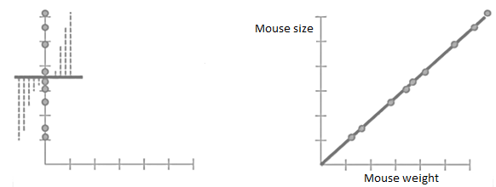
In this case, knowing mouse weight means you can make a perfect prediction of mouse size.
$$Var\left(mean\right)=11,1$$
$$Var\left(fit\right)=0→there are no residuals$$
$$R^{2}=\frac{11,1-0}{11,1}=1$$
In this case, mouse weight explains 100% of the variation in mouse size.
One last EXAMPLE …
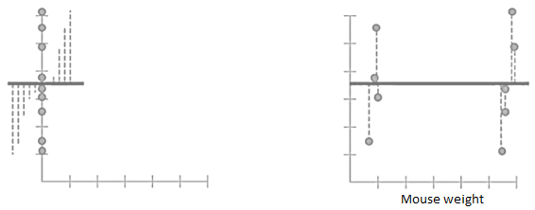
In this case, knowing mouse weight doesn´t help us predict mouse size at all.
$$Var\left(mean\right)=11,1$$
$$Var\left(fit\right)=11,1$$
$$R^{2}=\frac{11,1-11,1}{11,1}=0$$
In this case, mouse weight doesn´t explain any of the variation around the mean.

Let´s look at a slightly more COMPLICATED EXAMPLE …
Imagine wanted to know if mouse weight and tail length did a good job predicting the length of the mouse´s body.
So, we measure a bunch of mice and plot the results:
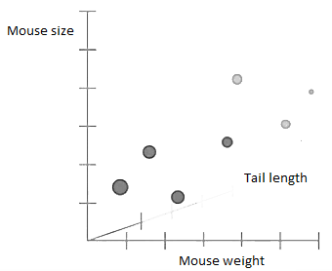
Since we have an extra term in the equation (representing an extra dimension), we fit a plane instead of a line. We do least squares fit to estimate 3 parameters:
$$y=0,1+0,7x+0,5z$$
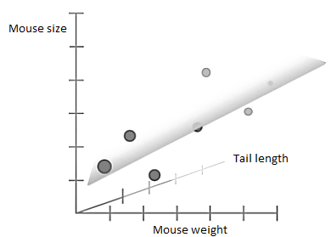
Just like before we can measure the residuals, square them, add them up, and calculate $R^{2}$.
Now, if the tail length is useless and doesn´t make SS(fit) smaller, than least-squares will ignore it by making that parameter 0.
$$y=0,1+0,7x+0z$$
This means equations with more parameters will never make SS(fit) worse than equations with fewer parameters.
In other words, this crazy equation …
$$Size=b+a_{1}×Weight+a_{2}×Flip of a coin+a_{3}×Astrological sign+…$$
… will never perform worse than this equation …
$$Size=b+a×Weight$$
This is because least-squares will cause any term that makes SS(fit) worse to be multiplied by 0, and in a sense, no longer exist.
But the more silly parameters we add to the equation, the more opportunities we have for random events to reduce SS(fit) and result in a better $R^{2}$. Thus, people report an adjusted R-squared value, that scales $R^{2}$ by the number of parameters.
P-VALUE
R-squared is awesome, but it´s missing something … We need a way to determine if the $R^{2}$ value is statistically significant ! We need a p-value !!!
We can think of R-squared as the (reduction invariance when we take weight into account) over the (total variance in size):
$$R^{2}=\frac{Var\left(size\right)-Var\left(fit\right)}{Var\left(size\right)}=0,6$$
$$R^{2}=\frac{variation in size explained by weight}{variation in size}=0,6$$
Meaning we saw a 60% reduction in variation once we took weight into account.
The p-value for R-squared comes from something called $F$:
$$F=\frac{variation in size explained by weight}{variation in size NOT explained by weight}$$
$$F=\frac{\frac{SS\left(mean\right)-SS\left(fit\right)}{\left(p_{fit}-p_{mean}\right)}}{\frac{SS\left(fit\right)}{\left(n-p_{fit}\right)}}$$
The highlighted numbers are degrees of freedom. They turn the sums of squares into variances.
$p_{fit}$ is the number of parameters in the fit line. In our example:$\tilde{y}=a x+b$, we had to parameters (the intercept and the slope).
$p_{mean}$ is the number of parameters in the mean line. In our example: $\overline{y}=mean$, we had only one parameter.
Both equations have a parameter for the y-intercept. However, the fit line has one extra parameter, the slope (which represents the relationship between weight and size). Thus, the numerator of $F$ is the variance explained by the extra the parameter (weight).
Ok, but why divide $SS\left(fit\right)$ by $(n-p_{fit})$ instead of just $n$ ? Intuitively, the more parameters you have in your equation, the more data you need to estimate them.
If the fit is good, then the variation explained by the extra parameters in the fit will be a large number, and the variation NOT explained by extra parameters in the fit will be a small number. That makes $F$ a really large number.
$$\frac{↑variation in size explained by weight}{↓variation in size NOT explained by weight}=F↑↑$$
But how di we turn this number into a p-value ??
1st, generate a set of random data, calculate the mean and the SS(mean), and calculate the fit and the SS(fit).
2nd, plug all those numbers into our equation for $F$ and that will give as a small number, like 2. Plug that number into a histogram.
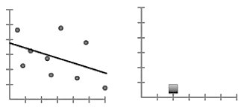
3rd, repeat steps 1 and 2 hundreds or even thousands of times, until you get a nice-looking histogram …
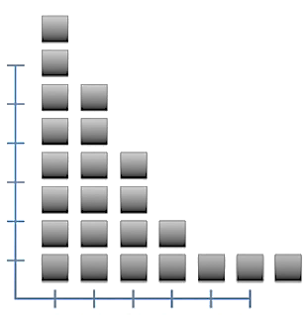
Once when we are all done with our random data sets, we return to our original dataset …
4th, we calculate $F$ for out fitted line. Say we get 6.
The p-value is the number of more extreme values (greater than 6) divided by the total number of values:
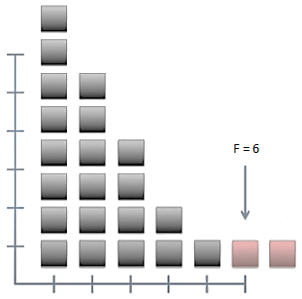
You can also approximate the histogram with a line. In practice, rather than generating tons of random datasets, people use the line to calculate the p-value.
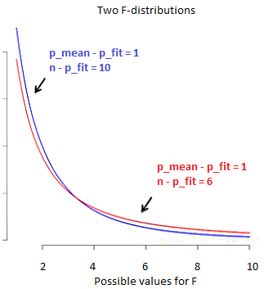
Notice than when $\left(n-p_{fit}\right)=10$ the distribution tapers off faster. This means that the p-value will be smaller when there are more samples relative to the number of parameters in the fit equation.
MAIN IDEAS: Given some data that you think are related LINEAR REGRESSION:
- Quantifies the relationship in the data (that is $R^{2}$, this needs to be large)
- Determines how reliable that relationship is (this is the p-value that we calculate with the F-distribution, and this needs to we small)
You need both (R-squared + p-value) to get an interesting result !!!

